Web Programming – PHP & MySQL

## Instructions for Setting Up the Week 8 Exercises

## 1. Create a New Folder:

## - In your local wp directory (that is in the htdocs directory of XAMPP), create a folder named week8.

## 2. File Placement:

## - Place all new files for the exercises inside the week8 directory.

## 3. Naming Conventions:

## - Ensure there are no spaces in any file or folder names.

## - Use only lowercase letters for naming folders and files.

## 4. Reasons:

## - Avoiding spaces and using lowercase helps ensure compatibility with web environments, including case-sensitive servers like those at RMIT.

## Exercise 1

Using phpMyAdmin create a database *destination* and inside of this database a table *country*. This table should have the following fields:

* countryid
* countryname
* description

*countryid* is a primary key and should be a *tinyint(4)*, it also should be serial or auto-increment. *description* is of *text* datatype.

All other fields are *varchar*. You can have different lengths for each of them. For example, *varchar(50)* for the name of the country.  
  
Create database

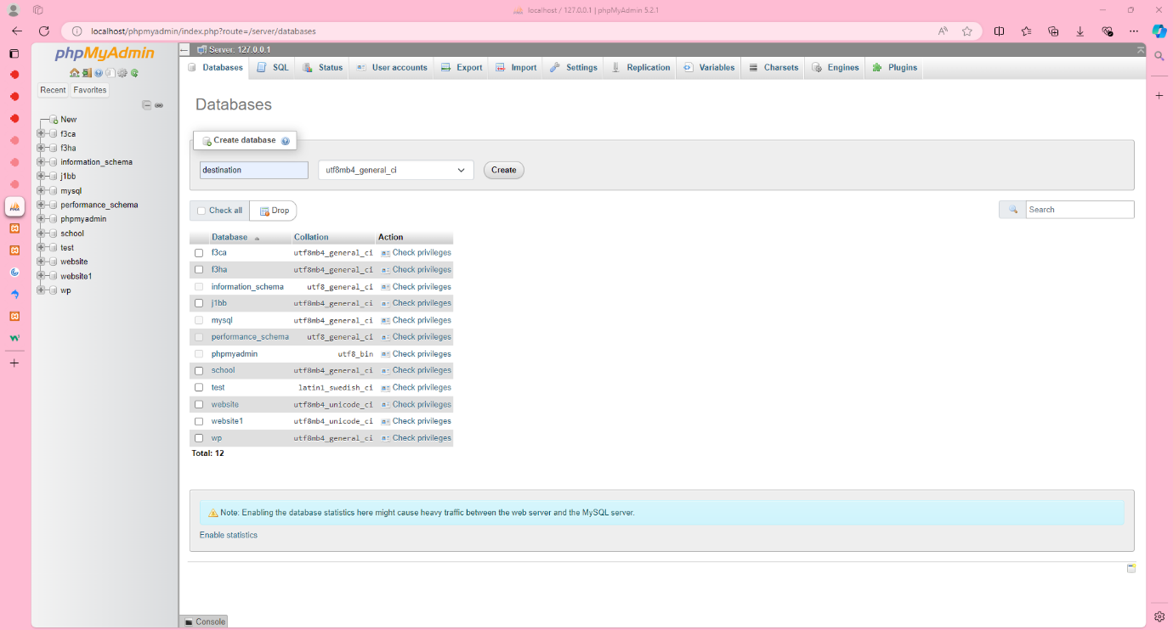  
Create table

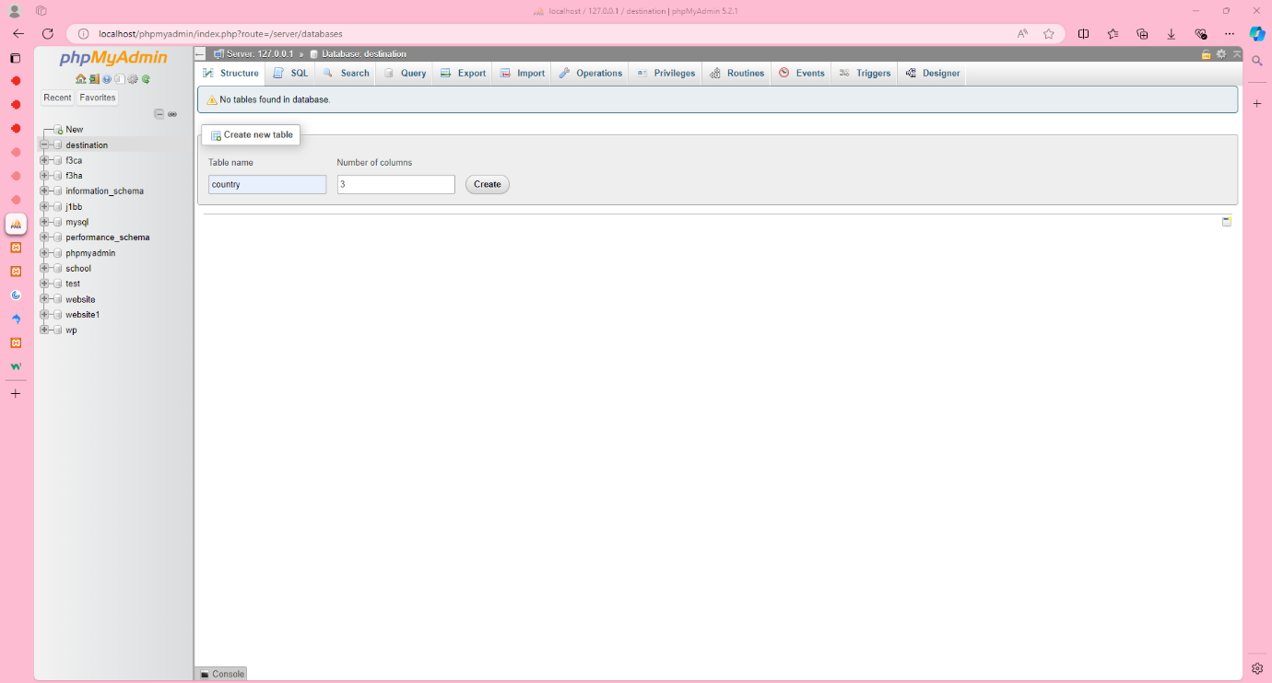

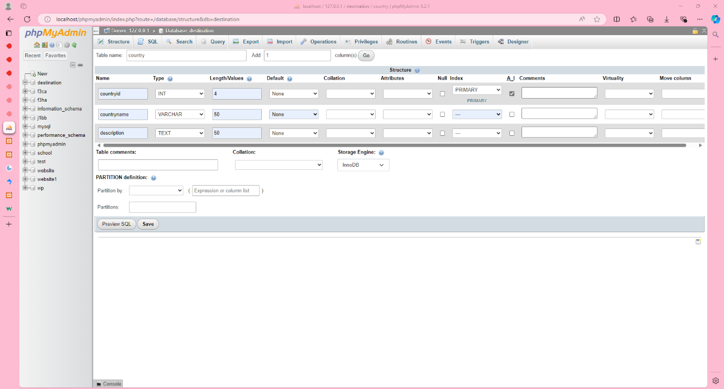

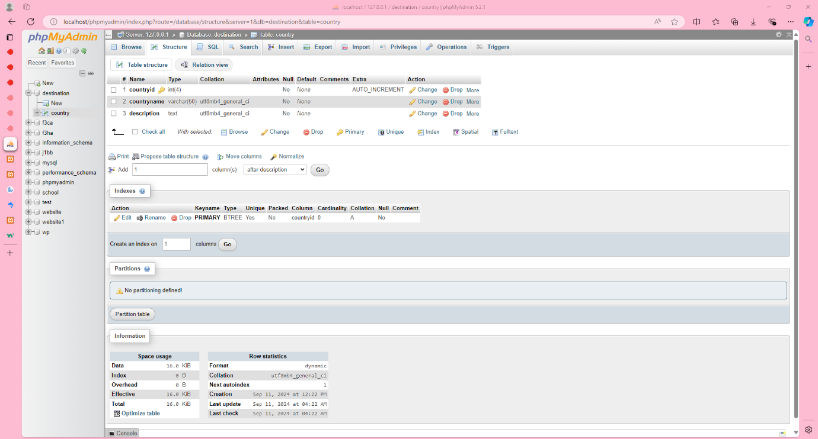

## Exercise 2

Add 3 records for Australia, Ukraine, and China using phpMyAdmin.

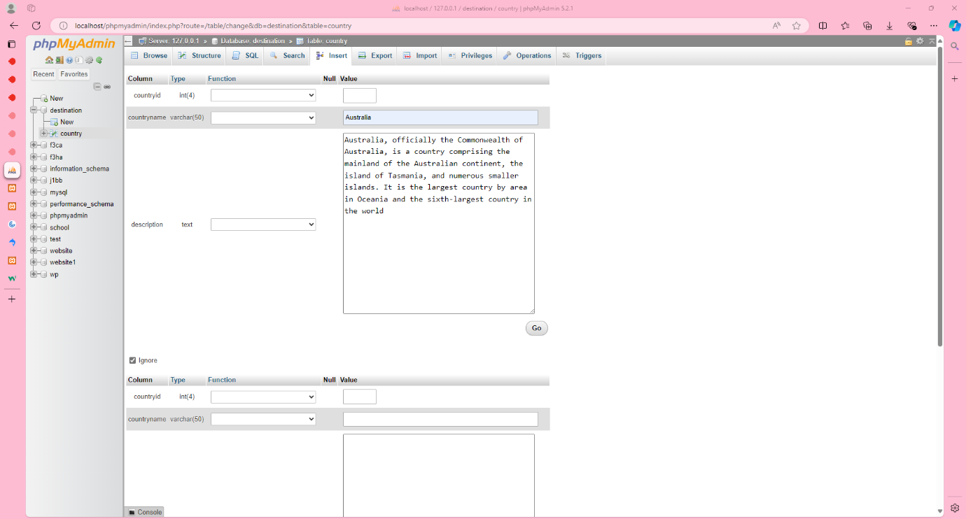

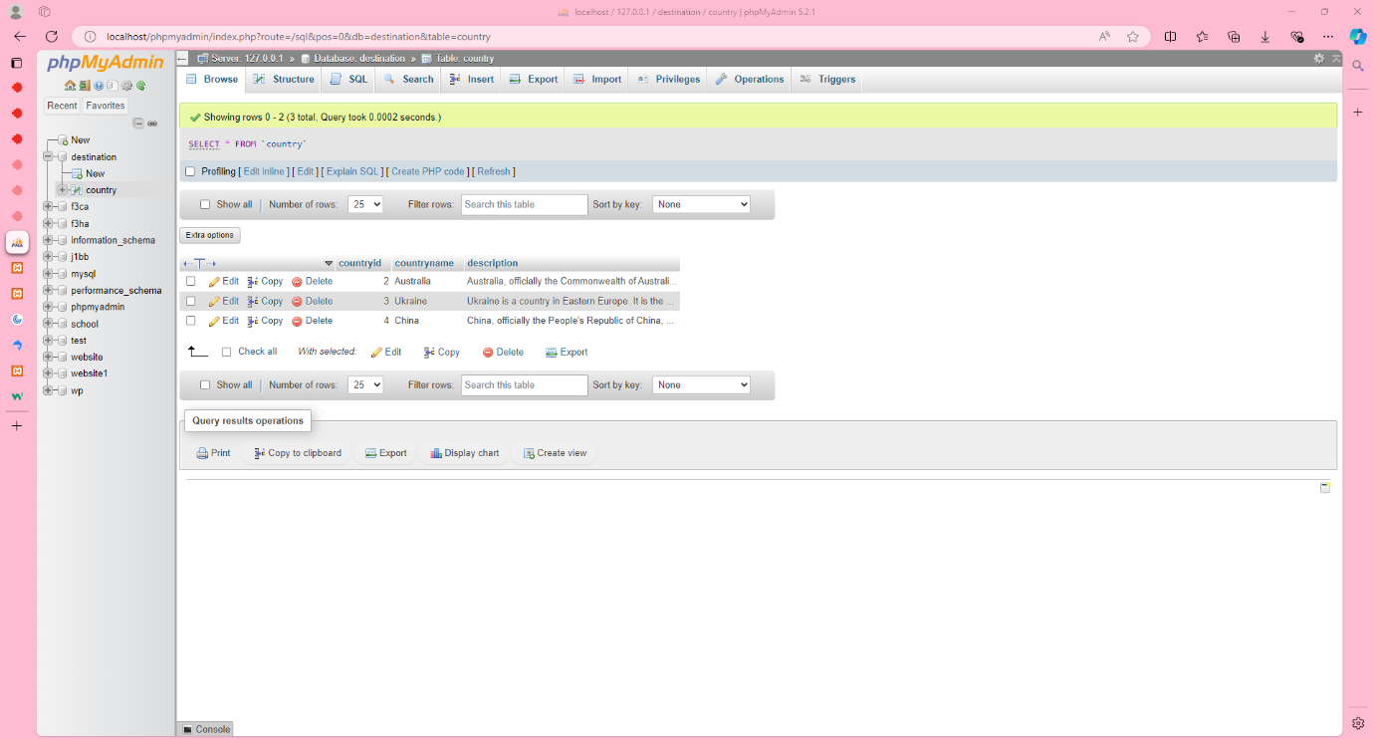

## Exercise 3

Log into the console and use mysql client to view databases, select *destination* database, view tables, and select all records from the *country*. Select from the *country* table only Australia (use WHERE clause).

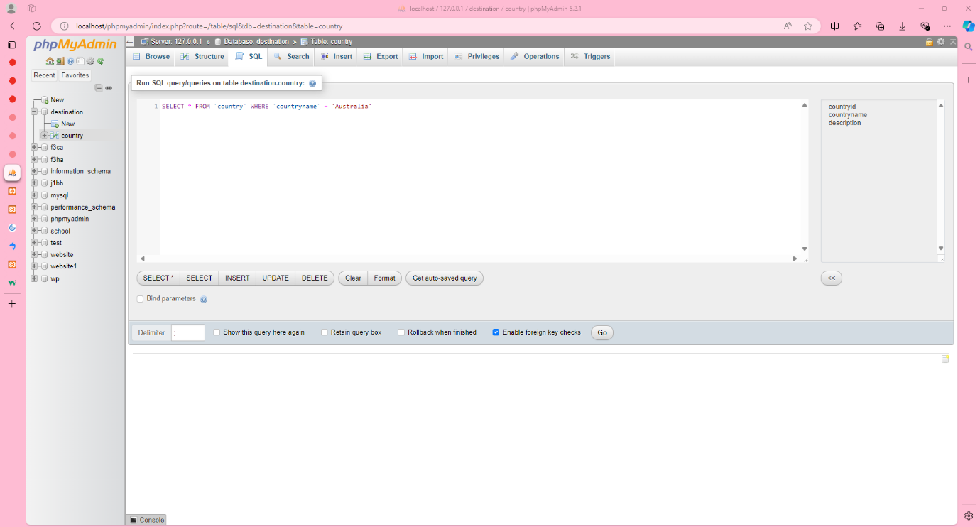

## Exercise 4

Create a file called *country.php* in a subdirectory (week8 or similar) of the *htdocs* directory of your XAMPP installation. Copy *header.inc* and *footer.inc* from week 7 into the subdirectory called *includes* which resides in the same directory as *country.php*. Add *include*() for *header.inc* and *footer.inc* into *country.php*. View it in a browser. You should have a resulting page of empty valid html. Check that the html is valid using W3C Validator.

Create a file called *db_connect.inc* in the *includes* directory. Add to this file a connection to the *destination* database. Check examples on Canvas (PowerPoint presentation, lecture notes). Use the *include*() function to include this file to *country.php*. Make sure that there are no errors when you view *country.php* in the browser.

Now you need to loop through the records in the country table. Use examples from Canvas as a guide. View *country.php* in the browser. You should see all records being displayed. Check that the html is valid using W3C Validator.

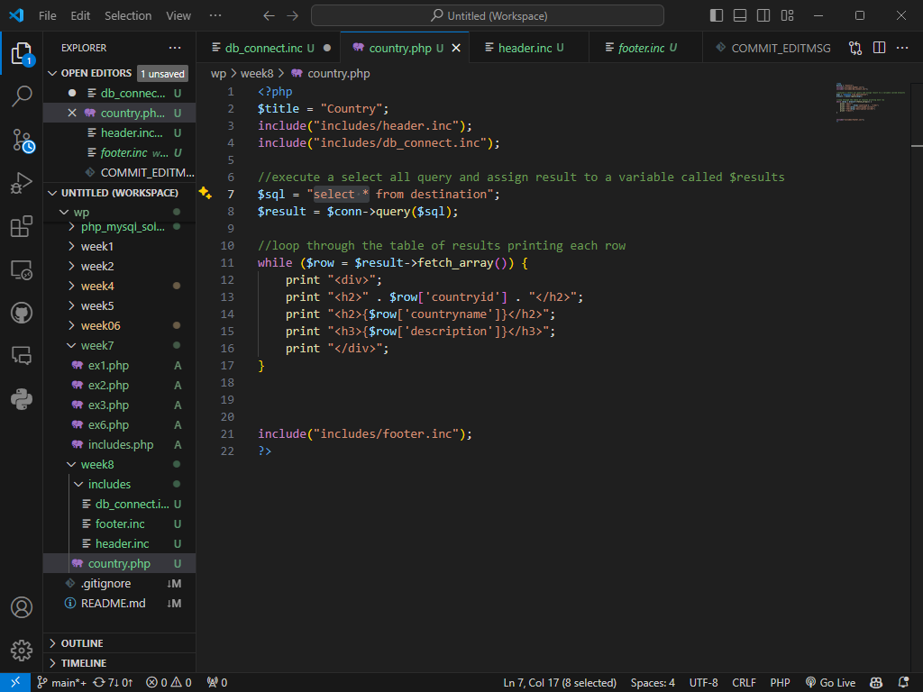

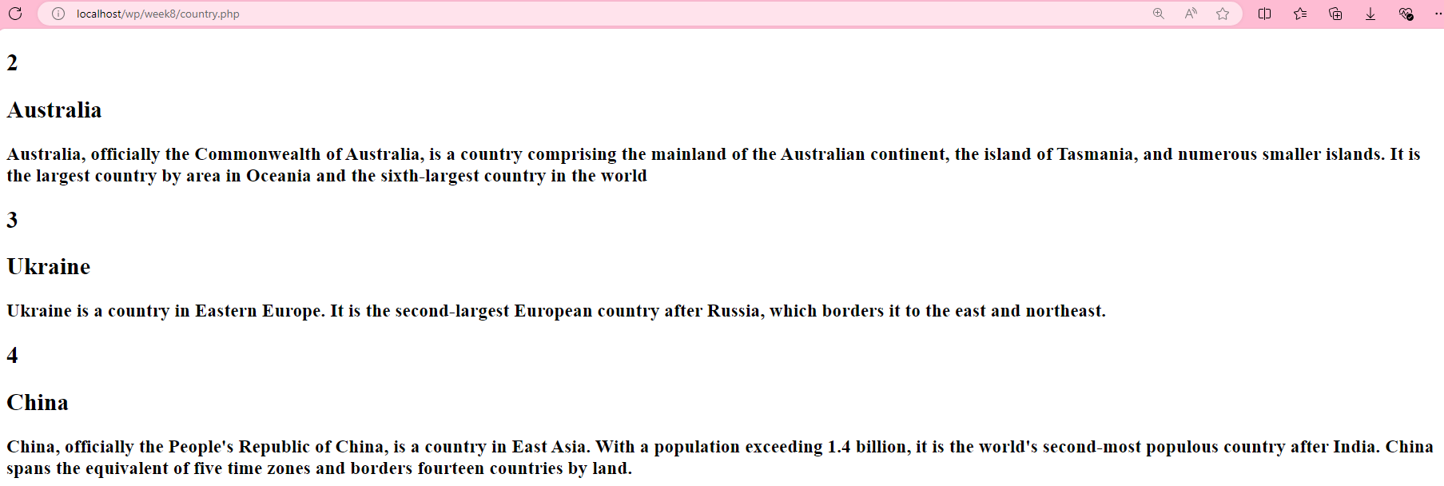

## Exercise 5

Add 3 more records for Indonesia, Japan, USA using INSERT INTO statements. View all records in the browser (*country.php*). You should see all 6 records displayed on the page.

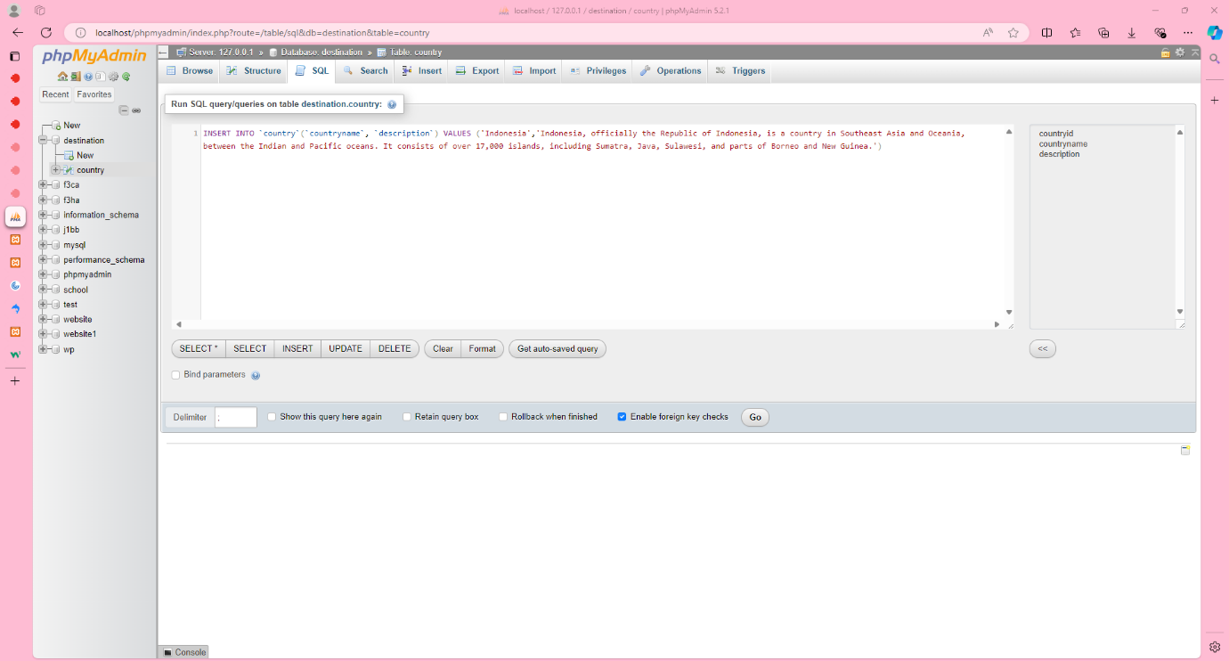

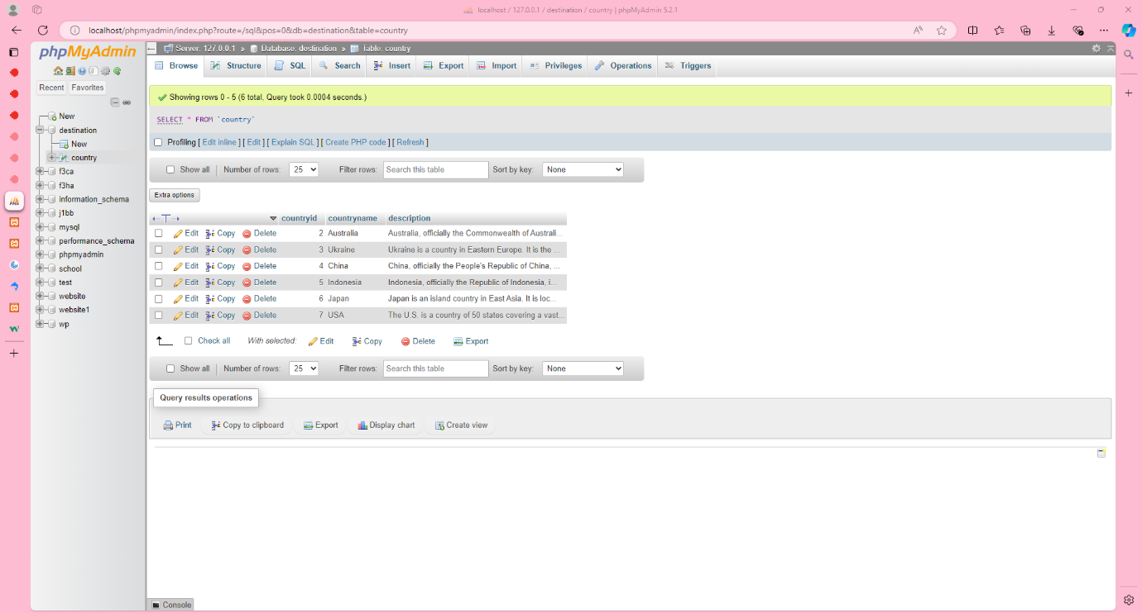

­­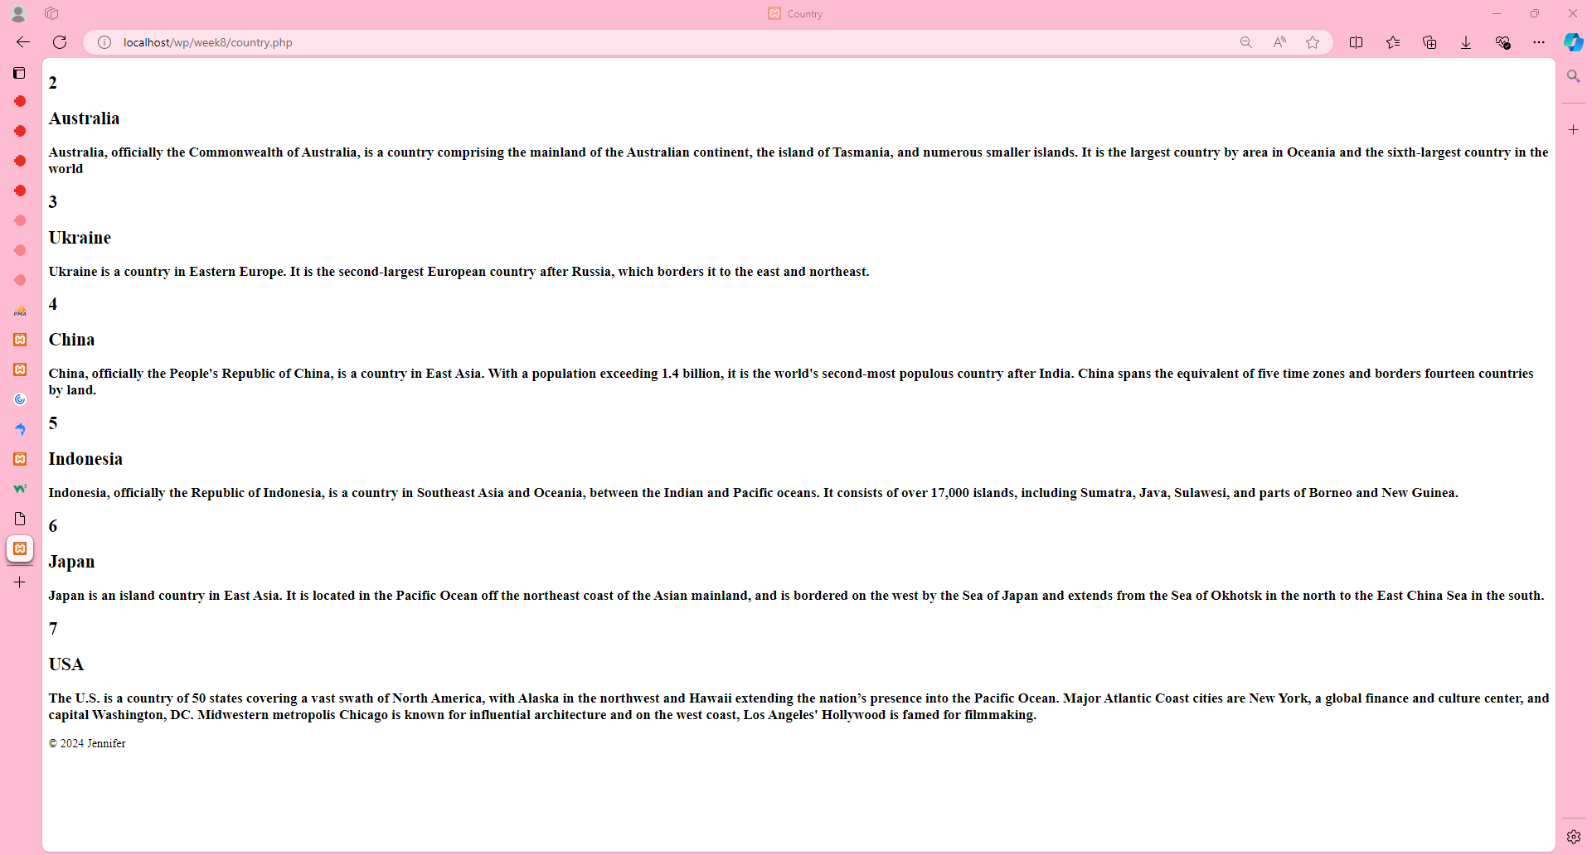

## Exercise 6

Download the *images.zip* file and place the *images* folder in the same directory as *country.php.*

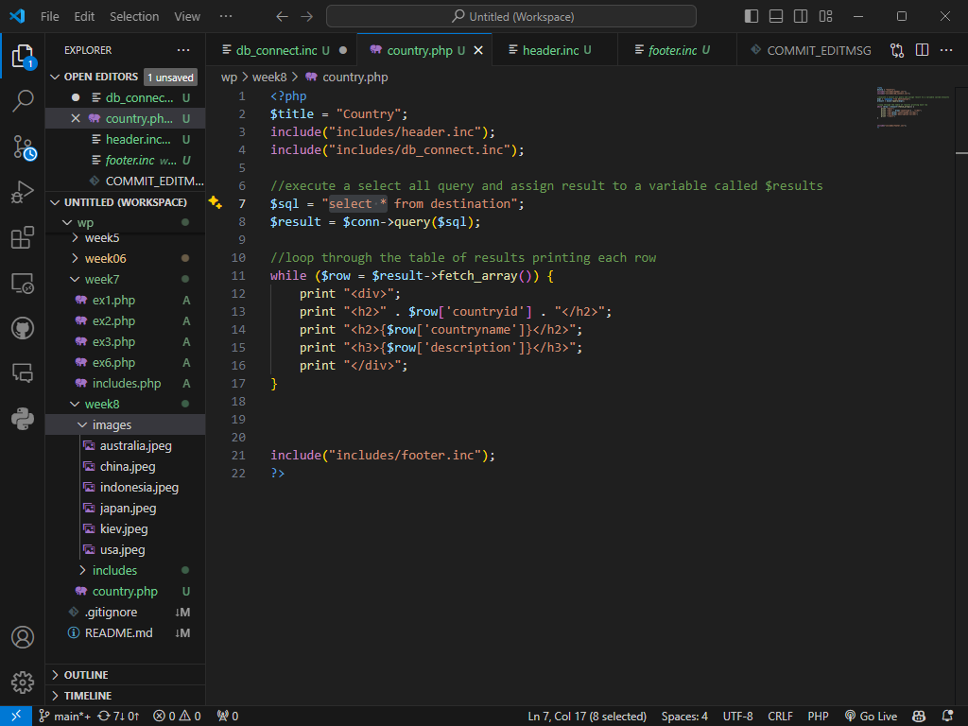

Add two columns to the *country* table for keeping image names and image descriptions (*alt* attributes):

`image` varchar(50) NOT NULL,

`caption` varchar(50) NOT NULL

Add the names of the images supplied to the newly created column. For example, add “kiev.jpeg” to the record of Ukraine. To the *caption* column add the names of the countries.

Modify *country.php* so it also displays images according to the database records.

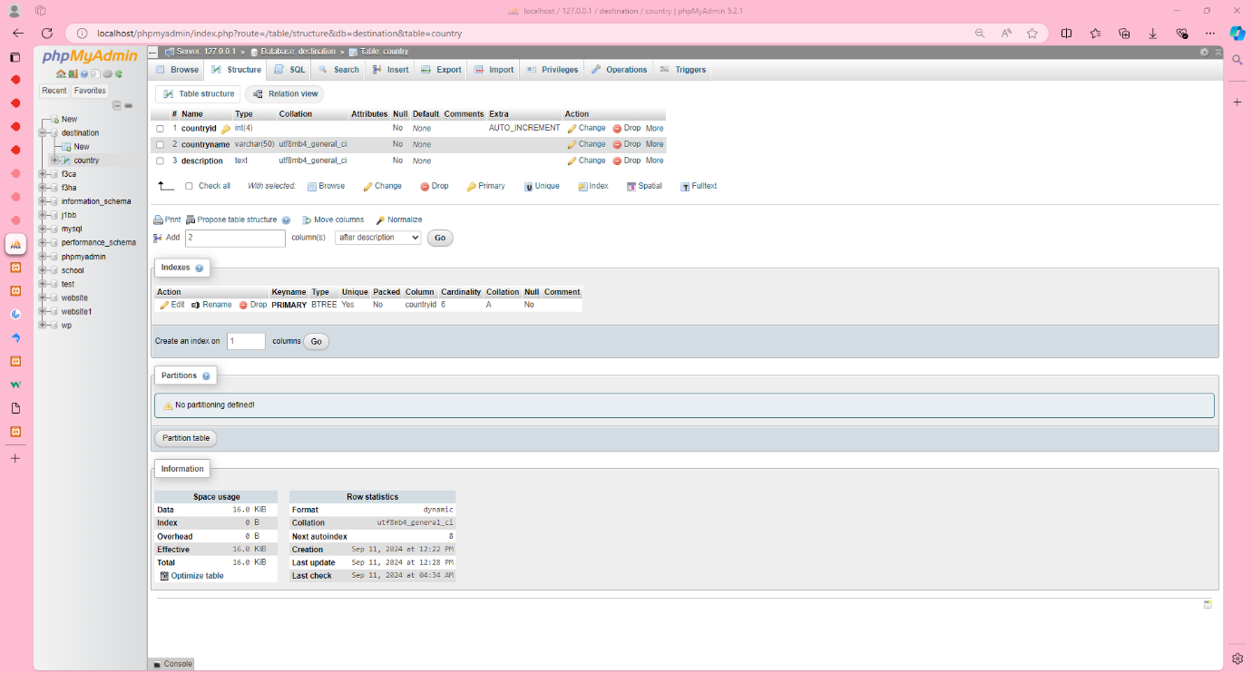

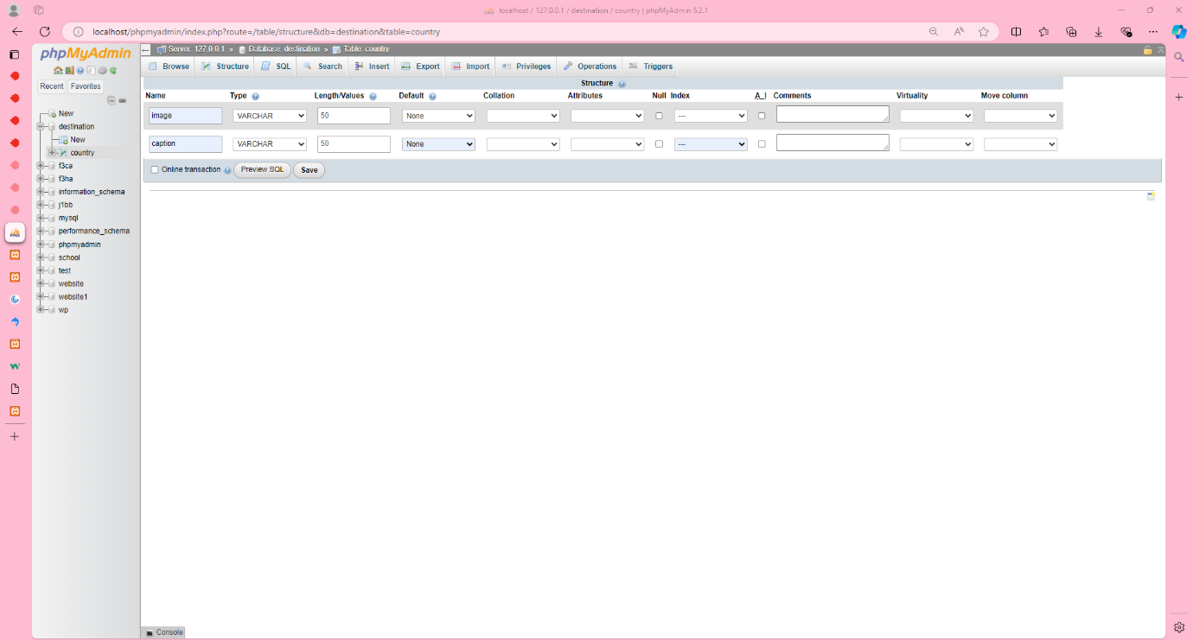

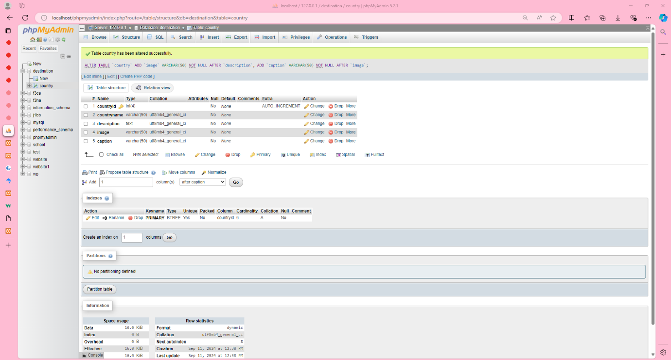

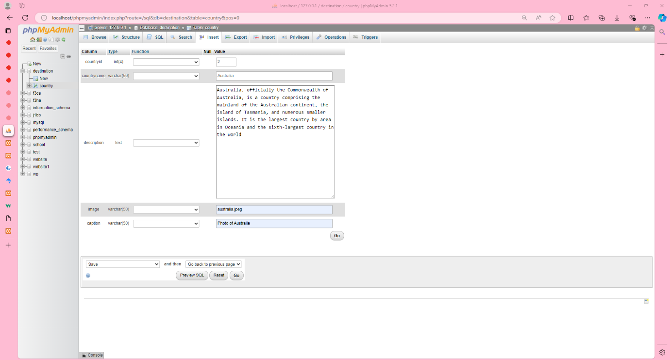

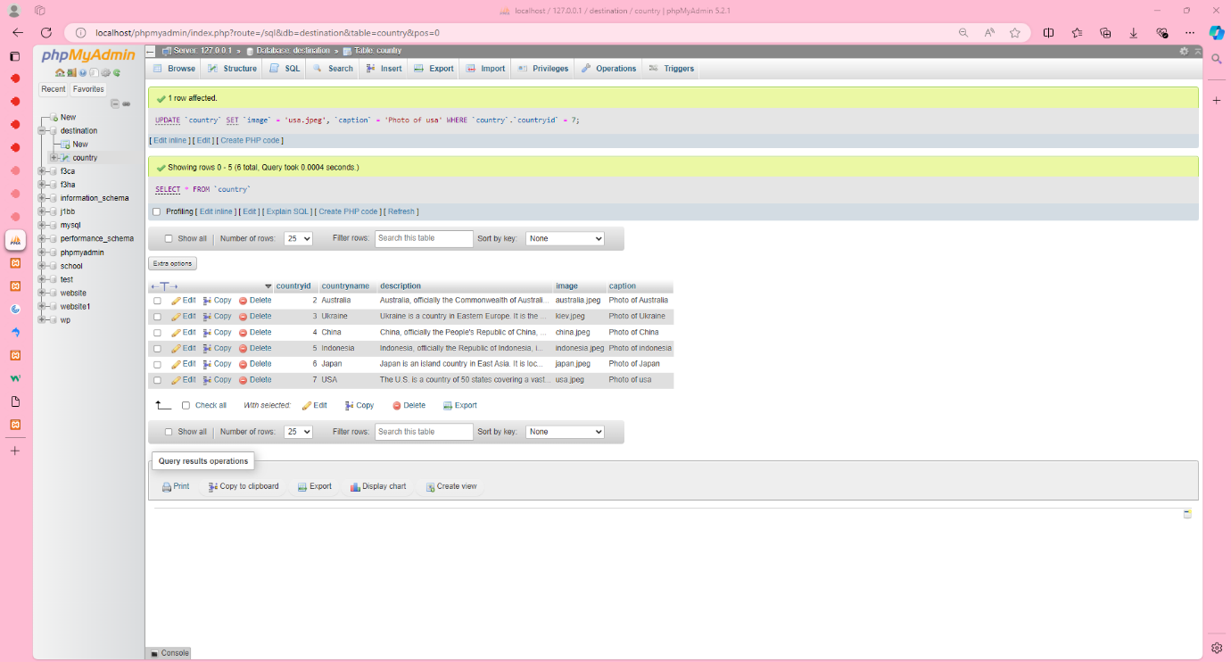

## Exercise 7

Export sql for *destination* database (mysqldump via phpMyAdmin).

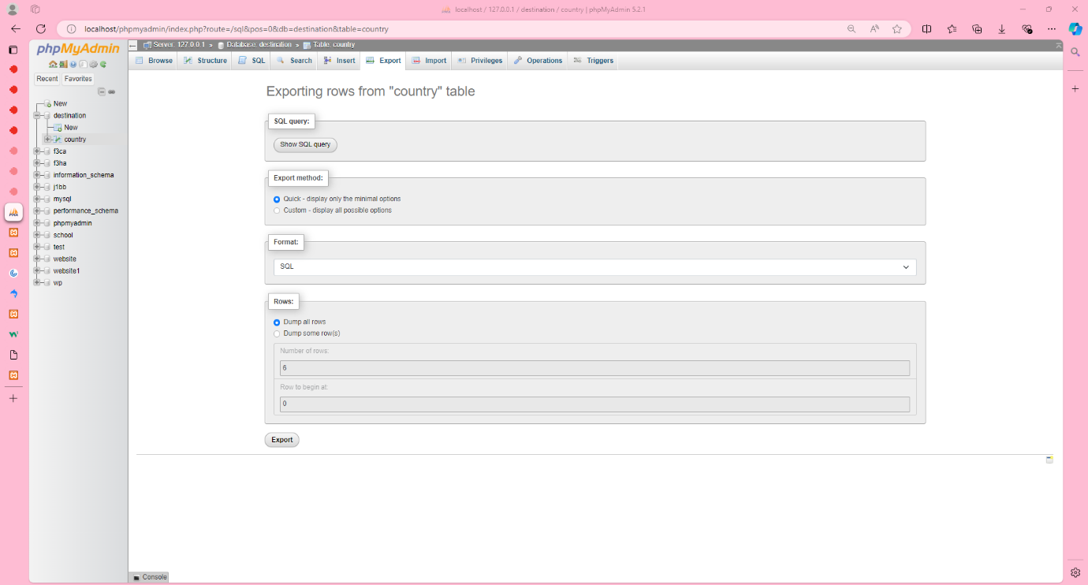

## Exercise 8

Create a table *country* in RMIT MySQL server Jacob 5. Please note that you need to use the database that has your student id name. Recreate the table and records in it. You have no permission to create databases on that server.

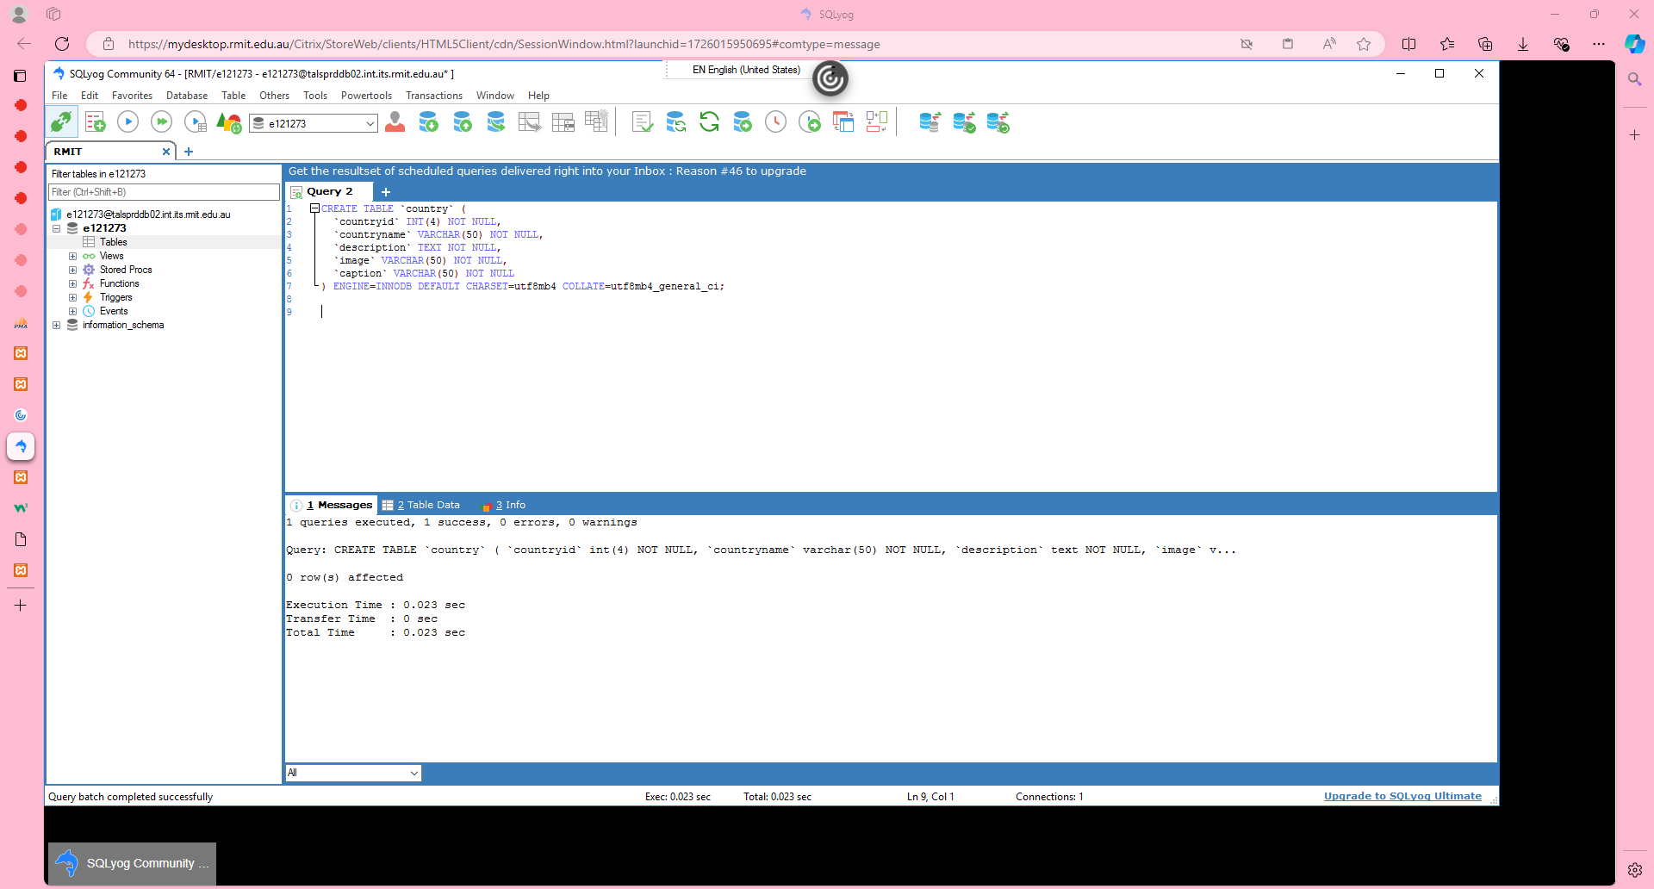

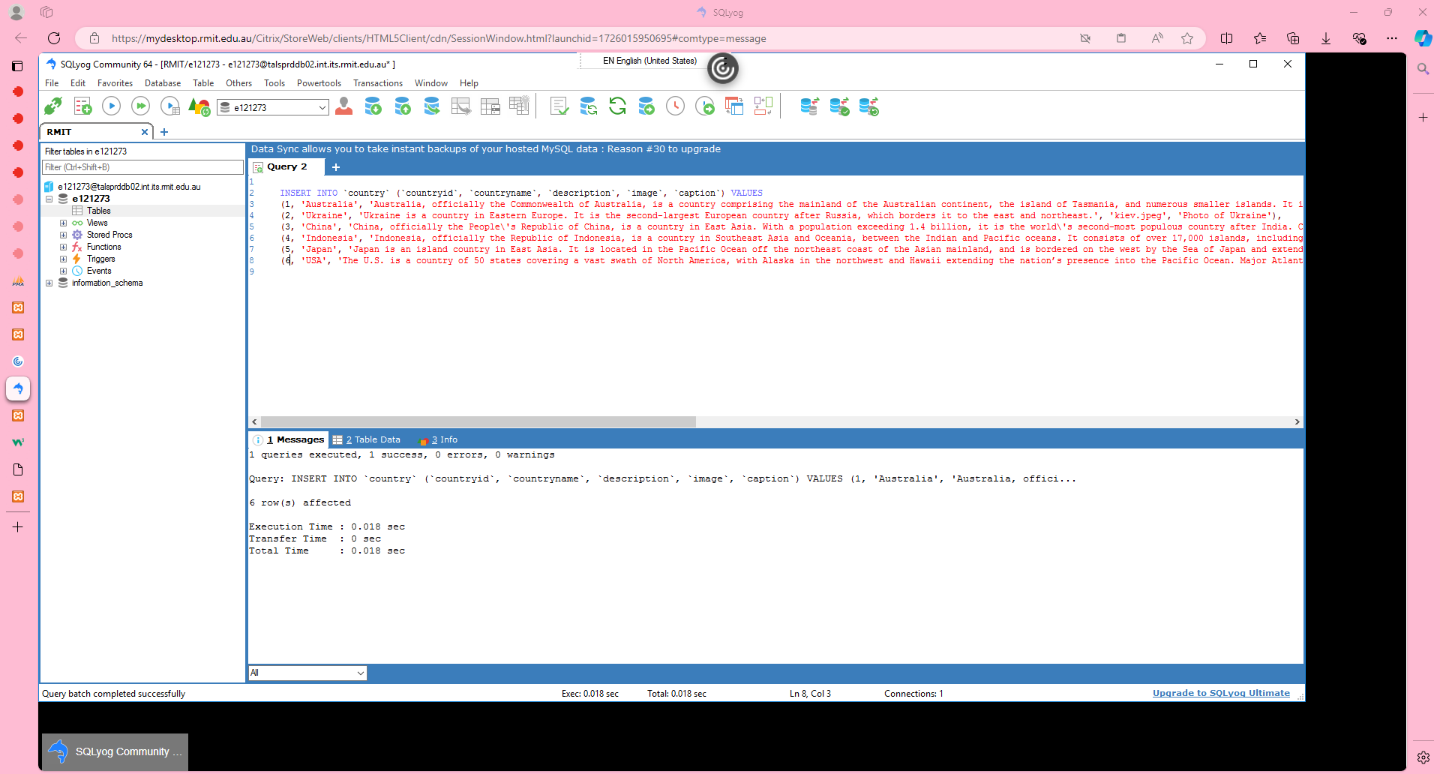

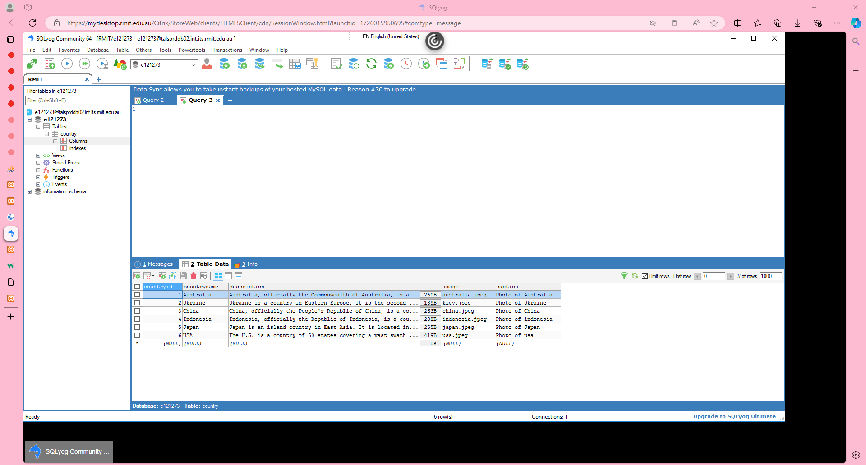

## Exercise 9

Copy your files from the XAMPP *htdocs* folder into Jupiter. Does the site work? If not, why?

Try to figure it out by yourselves. But if you fail, have a look at the solution – *db_connect.inc* file has changed.

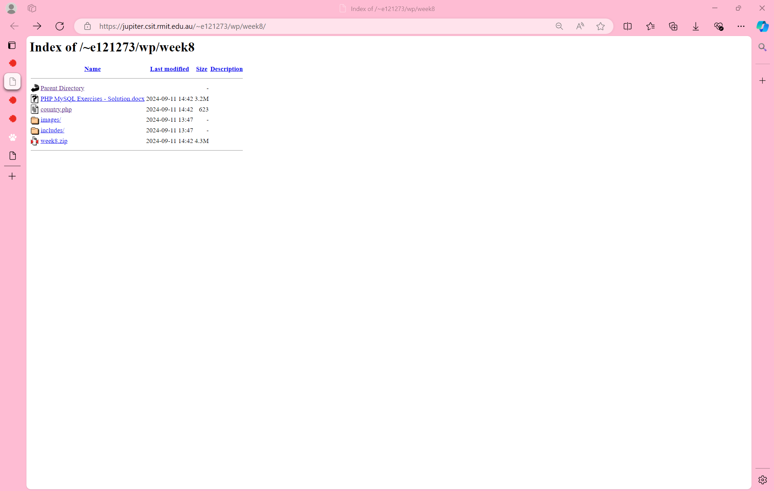

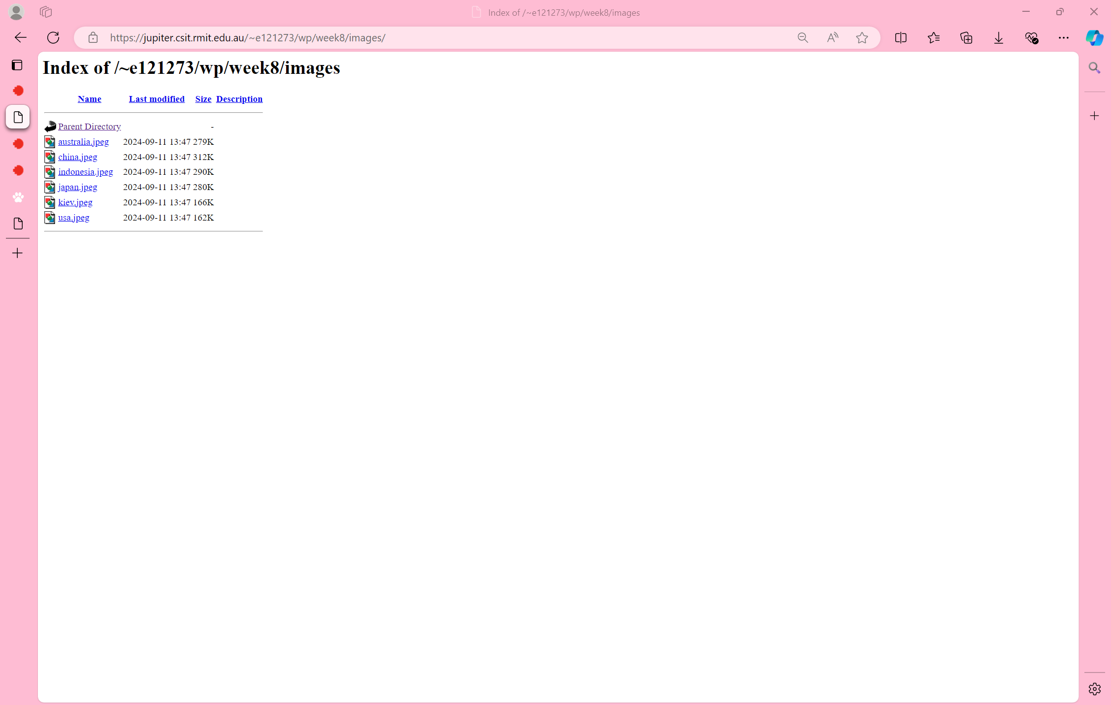

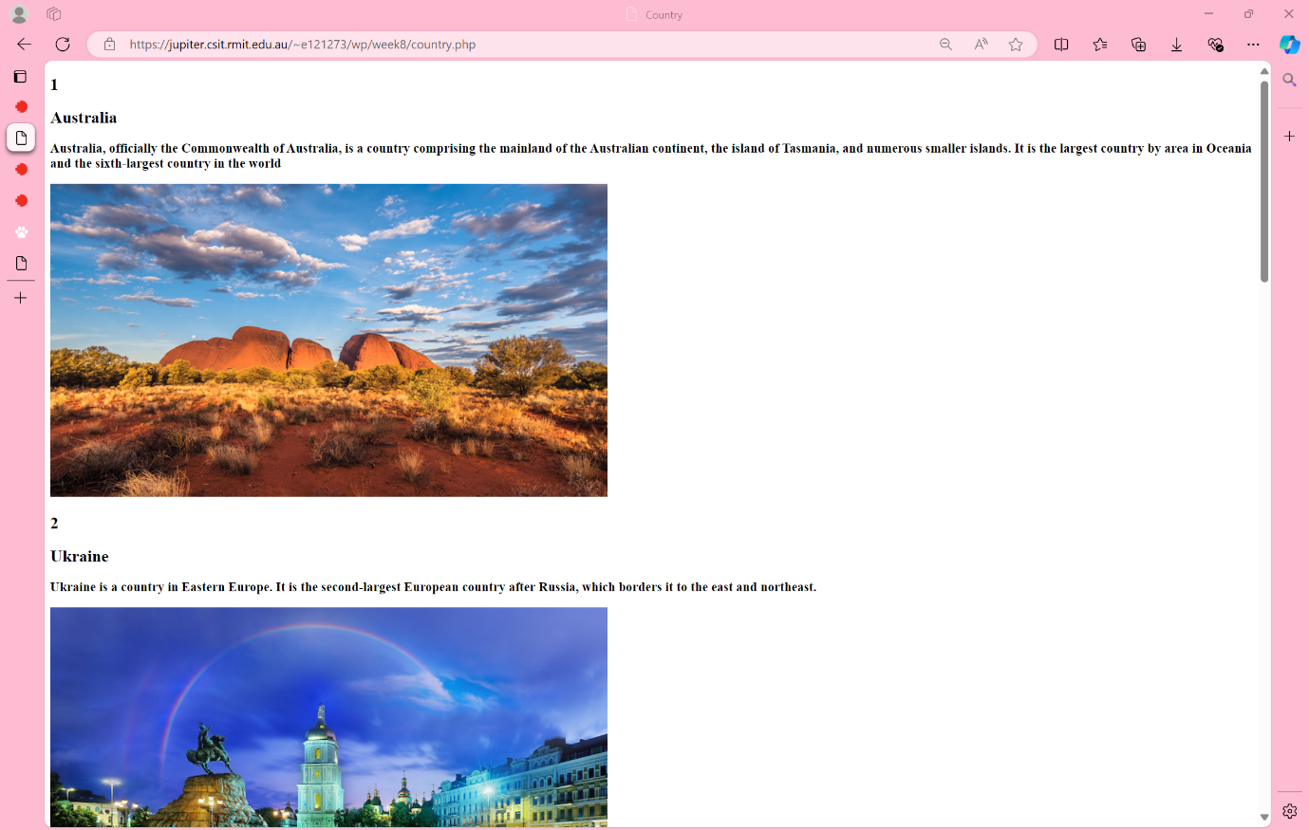

## Committing Exercise Files to Git via Visual Studio Code

1. **Open Your Project in VS Code**:

- Launch VS Code.

- Open your project folder (**week8**) by going to File > Open Folder and selecting your project directory.

2. **Stage Your Changes**:

- In VS Code, go to the Source Control panel (the icon looks like a forked branch on the sidebar).

- You'll see a list of untracked/changed files. Hover over the "Changes" section and click the '+' icon to stage all changes, or stage individual files by clicking the '+' icon next to each file.

3. **Commit the Changes**:

- After staging, type a commit message in the input box at the top of the Source Control panel. Follow best practices for commit messages (clear, concise, and descriptive).

- Click the Commit button and select “Commit & Sync” (you can also use “Commit & Push”)

## Deploy Code to the RMIT webserver

1. Open Terminal or Command Prompt:

- On your local machine, open your terminal or command prompt.

2. SSH into the Server:

- Use the command **ssh s1234567@titan.csit.rmit.edu.au** where s1234567 is your student ID

- Enter your RMIT password.

3. Navigate to the **wp** Directory:

- Once connected, navigate to the directory where your Git repository is located on the server using **cd ~/public_html /wp**.

4. Pull the Latest Changes:

- Run the command **git pull origin main** to pull the latest changes from the remote repository.

5. Exit SSH Session (optional):

- After pulling the changes, you can end your SSH session by typing **exit**